MECE 388 MATLAB Tutorial
MATLAB is used by engineers for analysis and design. There are so many different toolboxes available which extend the basic functions of MATLAB into different application areas (e.g. Bioinformatics Toolbox, Antenna Toolbox, Control System Toolbox, Econometrics Toolbox, etc.). In this tutorial, basic functions of MATLAB will be covered to make you familiar with MATLAB environment.

Variables
All MATLAB variables are multidimensional arrays.
Array Creation
To create an array with four elements in a single row, separate the elements with either a comma (,) or a space.

a = [1 2 3 4]
This type of array is a row vector.
Entering matrices into MATLAB is the same as entering a vector, except each row of elements is separated by a semicolon (;) or a return:

B = [1 2 3 4; 5 6 7 8; 9 10 11 12]
OR

B = [ 1 2 3 4
5 6 7 8
9 10 11 12 ]
If you want to create a vector with elements between 0 and 10 evenly spaced in increments of two (this method is frequently used to create a time vector):
t = 0:2:10
You may use “linspace” function to generate linearly spaced vectors, it is similar to the colon operator, ":", but gives direct control over the number of points and always includes the endpoints.
t = linspace(0,10,6);
TRY the following command line
t = linspace(0,20,10);
Another way to create a matrix is to use a function, such as ones, zeros, or rand. For example, create a 5-by-1 column vector of zeros.
z = zeros(5,1)
Matrix and Array Operations

MATLAB allows you to process all of the values in a matrix using a single arithmetic operator or function.

t + 10
t – 2
t * 3
t.^2 % Be careful it is an element-wise operator if you use with . (dot),
% otherwise you will get an error
Matrices in MATLAB can be manipulated in many ways. For one, you can find the transpose of a matrix using the apostrophe key:

C = B’

It should be noted that if C has been complex, the apostrophe would have actually given the complex conjugate transpose. To get the transpose in this case, use .' (the two commands are the same if the matrix is not complex).
Now you can multiply the two matrices B and C together. Remember that order matters when multiplying matrices.
D = B * C
D = C * B
Taking the power of each element
E = D.^2.3
Inverse of D

F = inv(E)
Polynomials:
Polynomials in s can be represented as row vectors containing the coefficients.
Thus P1 = s³ + 7s² - 3s + 23 can be represented by the vector shown below with elements separated by a space or comma.

P1 = [1 7 -3 23] % Store polynomial s^3 + 7s^2 -3s+ 23 as P1 and display.
rootsP1=roots(P1) % Find the roots of polynomial

Polynomials Using the s Variable:

Another way to represent a polynomial is to use the Laplace variable “s” within MATLAB. This method is mainly used throughout labs.
To define the variable, type the following into the MATLAB command window

s = tf('s')
polynomial = s^3 + 7*s^2 - 3*s – 23
We can use the zero function to find the roots of the polynomial

zero(polynomial)

Functions
MATLAB includes many standard functions. Each function is a block of code that accomplishes a specific task. MATLAB contains all of the standard functions such as sin, cos, log, exp, sqrt, as well as many others. Commonly used constants such as pi, and i or j for the square root of -1, are also incorporated into MATLAB. See the list of standard functions from MATLAB help.
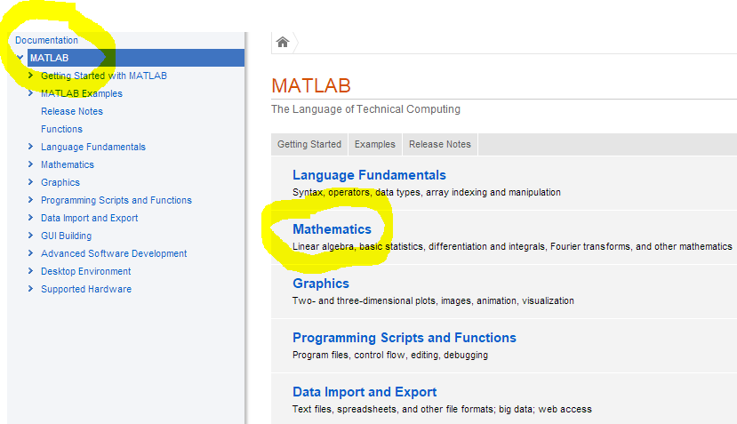
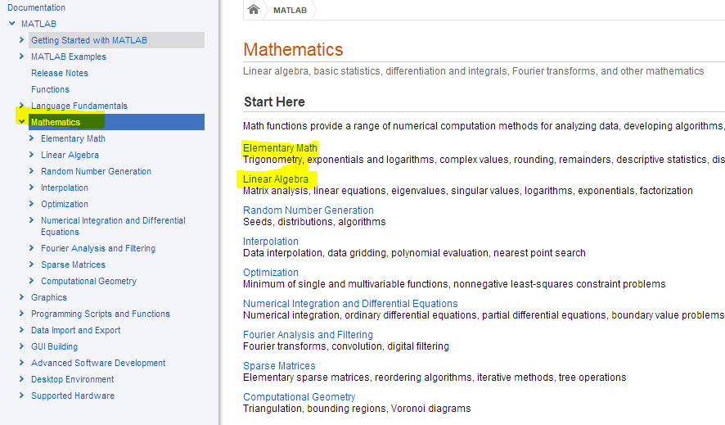
Write help commandname in MATLAB command window for more information on how to use any commands. Some of the commands used in this lab are listed in the following table.
Command | Description
abs | Absolute value
axis | Set the scale of the current plot, see also plot, figure
bode | Draw the Bode plot, see also logspace, margin, nyquist1
conv | Convolution (useful for multiplying polynomials), see also deconv
ctrb | The controllability matrix, see also obsv
deconv | Deconvolution and polynomial division, see also conv
det | Find the determinant of a matrix
eig | Compute the eigenvalues of a matrix
feedback | Connect linear systems in a feedback loop
figure | Create a new figure or redefine the current figure, see also subplot, axis
for | For loop
function | Creates function m-files
grid | Draw the grid lines on the current plot
help | Matlab help documentation
hold | Hold the current graph, see also figure
if | Conditionally execute statements
imag | Returns the imaginary part of a complex number, see also real
impulse | Impulse response of linear systems, see also step, lsim
input | Prompt for user input
inv | Find the inverse of a matrix
legend | Graph legend
length | Length of a vector, see also size
linspace | Returns a linearly spaced vector
lnyquist | Produce a Nyquist plot on a logarithmic scale, see also nyquist1
log | Natural logarithm, also log10: common logarithm
loglog | Plot using log-log scale, also semilogx/semilogy
logspace | Returns a logarithmically spaced vector
lqr | Linear quadratic regulator design for continuous systems, see also dlqr
lsim | Simulate a linear system, see also step, impulse
margin | Returns the gain margin, phase margin, and crossover frequencies, see also bode
minreal | Produces a minimal realization of a system (forces pole/zero cancellations)
norm | Norm of a vector
obsv | The observability matrix, see also ctrb
ones | Returns a vector or matrix of ones, see also zeros
plot | Draw a plot, see also figure, axis, subplot.
poly | Returns the characteristic polynomial
polyval | Polynomial evaluation
print | Print the current plot (to a printer or postscript file)
pzmap | Pole-zero map of linear systems
rank | Find the number of linearly independent rows or columns of a matrix
real | Returns the real part of a complex number, see also imag
rlocfind | Find the value of k and the poles at the selected point
rlocus | Draw the root locus
roots | Find the roots of a polynomial
set | Set(gca,'Xtick',xticks,'Ytick',yticks) to control the number and spacing of tick marks on the axes
sgrid | Generate grid lines of constant damping ratio (zeta) and natural frequency (Wn), see also sigrid, zgrid
size | Gives the dimension of a vector or matrix, see also length
sqrt | Square root
ss | Create state-space models or convert LTI model to state space, see also tf
step | Plot the step response, see also impulse, lsim
subplot | Divide the plot window up into pieces, see also plot, figure
text | Add a piece of text to the current plot, see also title, xlabel, ylabel, gtext
tf | Creation of transfer functions or conversion to transfer function, see also ss
tfdata | Access to transfer function data, see also ssdata
title | Add a title to the current plot
wbw | Returns the bandwidth frequency given the damping ratio and the rise or settling time.
xlabel/ylabel | Add a label to the horizontal/vertical axis of the current plot, see also title, text, gtext
zeros | Returns a vector or matrix of zeros
zgrid | Generates grid lines of constant damping ratio (zeta) and natural frequency (Wn), see also sgrid, sigrid

Examples:

' How are you?' % Display string.
-3.96 % Display scalar number -3.96.
-4 + 7i % Display complex number -4+7i.
-5-6j % Display complex number -5-6 j.
(-4+7i)+(-5-6i) % Add two complex numbers and display sum.
(-4+7j)*(-5-6j) % Multiply two complex numbers and display product.
M=5 % Assign 5 to M and display.
N=6 % Assign 6 to N and display.
P=M+N % Assign M+N to P and display.
Q=3+4j % Define complex number, Q.
MagQ=abs(Q) % Find magnitude of Q.
ThetaQ=(180/pi)*angle(Q) % Find the angle of Q in degrees.

numf=[7 9 12]; % Define numerator of F(s).
denf=conv(poly([0 -7]),[1 10 100]); % Define denominator of F(s).
[K,p,k]=residue(numf,denf) % Find residues and assign to K; find roots of denominator and
% assign to p; find constant and assign to k.

A transfer function can be expressed as a numerator polynomial divided by a denominator polynomial, that is, F(s) = N(s)/D(s).

' Vector Method, Polynomial Form' % Display label.
numf=150*[1 2 7] % Store 150(s^2+2s+7) in numf and display.
denf=[1 5 4 0] % Store s(s+1)(s+4) in denf and display.
' F(s)' % Display label.
F=tf(numf,denf) % Form F(s) and display.
clear % Clear previous variables from workspace.
' Vector Method, Factored Form' % Display label.
numg=[-2 -4] % Store (s+2)(s+4) in numg and display.
deng=[-7 -8 -9] % Store (s+7)(s+8)(s+9) in deng and display.
K=20 % Define K.
' G(s)' % Display label.
G=zpk(numg,deng,K) % Form G(s) and display.
clear % Clear previous variables from workspace.
' Rational Expression Method, Polynomial Form' % Display label.
s=tf('s') % Define's'as an LTI object in polynomial form.
F=150*(s^2+2*s+7)/[s*(s^2+ 5*s+4)] % Form F (s) as an LTI transfer function in polynomial form.
G=20*(s+2)*(s+4)/[(s+7)* (s+8)*(s+9)] % Form G(s) as an LTI transfer function in polynomial form.
clear % Clear previous variables from workspace.
' Rational Expression Method, Factored Form' % Display label.
s=zpk('s') % Define's'as an LTI object in factored form.
F=150*(s^2+2 * s+7)/[s *(s^2+5*s+4)] % Form F(s) as an LTI transfer function in factored form.
G=20*(s+2)*(s+4)/[(s+7)*(s+8)*(s+9)] % Form G(s) as an LTI transfer function in factored form.

